MARKHAM AFRICAN CARIBBEAN CANADIAN ASSOCIATION

2020 SCHOLARSHIP APPLICATION PACKAGE
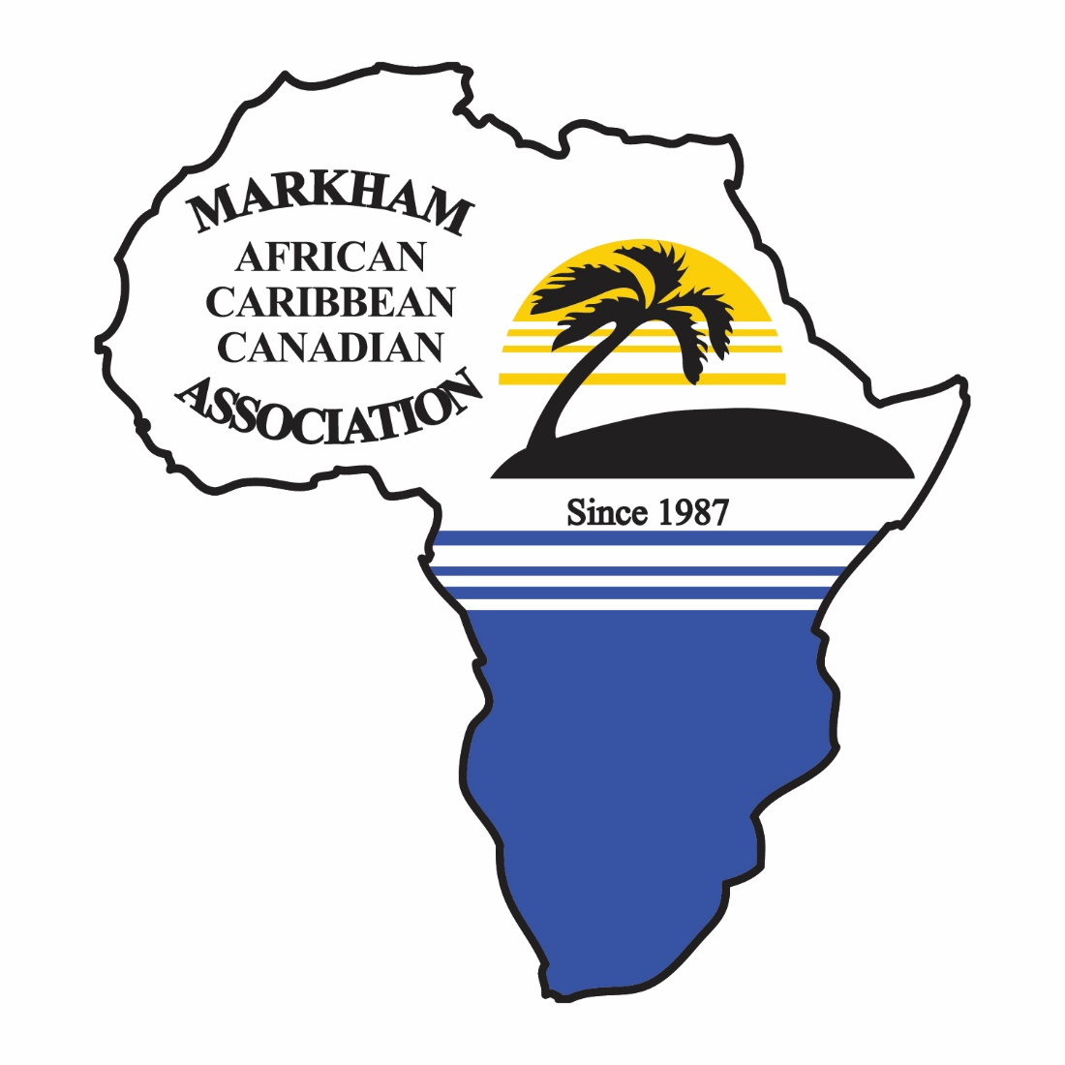

Reaching Out to Serve Others

This package is intended for potential scholarship participants.

Information and Instructions

General Information

The Markham African Caribbean Canadian Association (MACCA) will be awarding Scholarships of $1,000 to each selected recipient. Selection is based on students’ involvement and dedication to their community and academic achievements. One outstanding student that excels in these areas and demonstrates that they have gone above the and beyond will receive the President’s award.

Application forms can be picked up at your school’s guidance office or by contacting the Markham African Caribbean Canadian Association (MACCA).or downloading it from the website. www.macca1987.com

Eligibility

- Applicant must be of Caribbean or African Heritage
- Applicant must reside and attend school in York Region or volunteered at a MACCA Program for at least two years
- Applicant must be accepted and enrolled in full-time studies at an accredited Canadian college, University trade school/ apprenticeship program during the 2020-2021 academic year.
- Applicant must provide proof of community involvement and extra-curricular participation
- Applicant must have an overall academic average of B+ or above

Application Instructions

A complete application should be mailed to MACCA by Friday, June 26, 2020.
Please refer to the application checklist that is attached as part of the application package. This checklist is to be signed and placed at the front of your complete application package. Incomplete application packages will not be considered.

Interviews will be conducted during the week of July 13 to 17, 2020, and successful candidates will be notified by Friday, August 7, 2020.

If you have been selected to receive the MACCA Scholarship, you will be required to provide two photographs and your social insurance number for tax purposes.

In addition, we require successful recipients to dedicate 20 hours of community hours to the MACCA organization serving in one or more of the following programs and events. You have one full year to complete the 20 hours. Please select the programs and events you would like to contribute to if you were to be successful.

- Summer Reading and Robotics Camp
- Seniors Program
- MACCA Walkathon
- Saturday School Program
- MACCA Youth Council
- KINNECTYOUTH Mentoring Program
- MACCA Steel Pan Program

Mail your completed application package and all related documents to:

Markham African Caribbean Canadian Association (MACCA)
505 Hood Road, Unit 5
Markham, ON, L3R 5V6
Attention: Scholarship Awards Committee
Email: info@macca1987.com

For further information about the MACCA Scholarship please contact us at
(905) 946-9998 or via email at info@macca1987.com.

MACCA SCHOLARSHIP CHECKLIST
Please ensure that you have completed the application form and submitted all the required documents. Incomplete applications will not be considered.

You must include two (2) copies of your application and short essay. Only one (1) copy of your transcript needs to be submitted.

This checklist has been provided to help you make sure that all the required information has been included with your application package.
Application must be stapled together and submitted in this order. (From pages 5 through 13).

__ Part 1, 2, 3, 4, 5 and 7 have been filled out

__ I have attached my short essay (Part 6)

__ I have attached an official copy of my current transcript

__ I have attached two (2) letters of reference, including their contact information
(Part 7)

__ I have included a copy of the Letter of Acceptance to the University or
College I am enrolled in for the 2020-2021 academic year

__ I have included a signed copy of the Video & Media Coverage Release Form

__ I have attached the checklist to the front of my completed package

I, the undersigned, declare that to the best of my knowledge, all of the above information is accurate and true. I have included all the required information to be considered for the Markham African Caribbean Canadian Association (MACCA) 2020 Scholarship.

_______________________________________ ________________
Applicant Signature Date

I would like the Markham African Caribbean Canadian Association to:

__ Inform me of upcoming events and volunteer opportunities

__ Add me to their mailing list

__ I would like to become a member of the Markham African Caribbean
Canadian Association

PLEASE PRINT CLEARLY – USE A PEN OR TYPE

Part 1: Contact Information

Please ensure that you provide the most current information because this is how we will contact you.

Your Name:

First: ___________________________________________________________

Last: ___________________________________________________________

Your Address:

Street: __________________________________________________________

City: _________________________ Province: _______

Postal Code: _______________________

Home phone number: (_____) ________________________

Cell phone number: (_____) _________________________

Email Address: __________________________________________________

Part 2A: Academic Information

Secondary School Name: __________________________________________

Address: ________________________________________________________

City: _________________________ Province: _______

Postal Code: ______________________

Phone number: (_____) ________________________

Part 2B: Academic Achievements

Please ensure that an official copy of your current transcript is attached to this application.

Grade 12 Academic Achievement
Course | Grade | Course | Grade

Awards and Honours
Award/Honour | Year Received

Part 2C: School Involvement

Please list all extra-curricular activities that you have been involved in through your high school. These may include clubs, student council, sports, etc.

Extra-curricular Activity | Role/Responsibilities | Year

Part 3: Community Involvement

Please list all community service, volunteer involvement, recreational and other activities that you are involved in outside of school. Please provide details.

Organization/  Agency | Position/Role | Year

Part 4: Post-Secondary Plans

Post-secondary Institution: ________________________________________

Program/Area of Study: __________________________________________

________________________________________

Part 5: Awareness of MACCA

Have you ever attended a MACCA event? _______

If yes, which ones? (Please list) ________________________________________________________________________________________________________________________________________________________________________________________________________________________________________________________________________________________________________________________________

Have you heard of M.A.C.C.A. before applying for this scholarship? ________

If yes, please provide details.

Part 6: Short Essay

Outline in a short-essay the importance of your education, community involvement/service and volunteer work on your decision to pursue your future goals. You must also include in your essay the importance of being awarded this scholarship by MACCA and how it would help you in achieving your goals.

This essay must be approximately 250 words in length.

Make sure that you include your first and last name on your essay.

Part 7: Letters of Recommendation

Provide two (2) letters of recommendation from two individuals who know you well and can comment on your community involvement, volunteer work and/or your academic achievements. One letter must be from a teacher at the high school that you are currently attending. The second letter must be from someone whom you have worked with in the community and can comment on your community involvement and achievements. These individuals must either live or work in York Region.

Please provide their names and phone numbers in the table below.

References
Name (First & Last) | Phone Number
Reference 1:

Reference 2:

VIDEO & MEDIA RELEASE FORM
The Markham African Caribbean Canadian Association (MACCA) is a charitable organization that is involved in various events and presentations within the Markham and York Region community. On occasion, our events are covered by the media who may use formats including:

- Internet
- Television
- Newspaper
- Photographs
- Video Footage
- Voice recordings

Media coverage is strictly for MACCA’s use and may be used in conjunction with other events, planning for advertising, promotional, and community awareness purposes. There is no time limit to the use of such media.

This Video & Media Coverage Release Form acknowledges and governs that only MACCA can/will use the various media coverage for the purposes mentioned above; no other use of media that is not set forth and listed above by MACCA will be authorized.

By signing below, you have read, understood, and agreed to the terms set out above.

Name (please print): _______________________________________________

Address: ________________________________________________________

________________________________________________________
Telephone Number: _______________________________________________
Email Address: ___________________________________________________
Signature: _______________________________________________________
Date: ____________________________

